To complete this worksheet, see the instructions in the textbook (Chapter 5 Investigation).

|  |  |  |  |
| --- | --- | --- | --- |
| **Table 1. Interpretation of Features, Tectonic Settings, and Causes of Melting** | | | |
| For each site on figure 5.15.a1 in the Chapter 5 Investigation in the textbook (also found on page 3 of this worksheet), enter the following:   * the general name of the feature, such as mid-ocean ridge or continental arc; * the type of plate boundary or other setting. Possible choices include: (1) oceanic divergent, (2) continental rift, (3) ocean-ocean convergent, (4) ocean-continent convergent, (5) continental collision, (6) hot spot in an ocean, (7) hot spot in a continent, or (8) other (explain what you think the feature is). Not all of these settings are present in this area; * the most likely cause of melting. The options are (1) decompression melting, (2) melting by adding water, and (3) melting of continental or oceanic crust caused by an influx of mantle-derived magma. | | | |
| **Site** | **Name of Feature** | **Type of Plate Boundary  or Other Feature** | **Likely Cause of Melting** |
| A |  |  |  |
| B |  |  |  |
| C |  |  |  |
| D |  |  |  |
| E |  |  |  |

|  |  |  |  |  |  |
| --- | --- | --- | --- | --- | --- |
| **Table 2. Characterization of Rock Samples** | | | | | |
| For each of the samples(shown in textbook section 5.15), indicate (1) whether each rock shown is coarsely crystalline, finely crystalline, or has other distinctive igneous textures, (2) whether it is probably felsic, mafic, or intermediate, (3) the name you would apply to such a rock, such as granite or basalt; (4) the cooling and solidification history of the rock (slow, moderate, fast, slow then fast, or slow cooling in the presence of water) based on its texture, (5) the viscosity and, (6) the type of volcanic eruption for volcanic rocks. | | | | | |
| **Sample** | **Crystal Size or Other Texture** | **Composition (F=felsic,  M=mafic, or I=intermediate)** | **Name of Rock** | **Cooling and Solidification History** | **Viscosity  (low or high) and Type of Eruption for Volcanic Rocks** |
| 1 |  |  |  |  |  |
| 2 |  |  |  |  |  |
| 3 |  |  |  |  |  |
| 4 |  |  |  |  |  |
| 5 |  |  |  |  |  |
| 6 |  |  |  |  |  |
| 7 |  |  |  |  |  |
| 8 |  |  |  |  |  |
| 9 |  |  |  |  |  |

|  |
| --- |
| **Tectonic Settings of Igneous Activity** |

The area below has five sites, labeled A, B, C, D, and E, where igneous activity has been observed. For each site, consider the igneous processes responsible for the activity, such as the type of plate boundary or other feature. Possible choices are listed in Table 1.

Site A: A line of volcanic islands and submarine mountains. Broad volcanoes on the islands are forming dark volcanic rocks. [Sample 1]

Site D: Volcanoes on top of a mountain belt near the edge of the continent. The volcanoes erupt light-colored and gray volcanic rocks. Older intrusive rocks, some with coarse crystals, are also exposed. [Samples 5, 6, and 7]

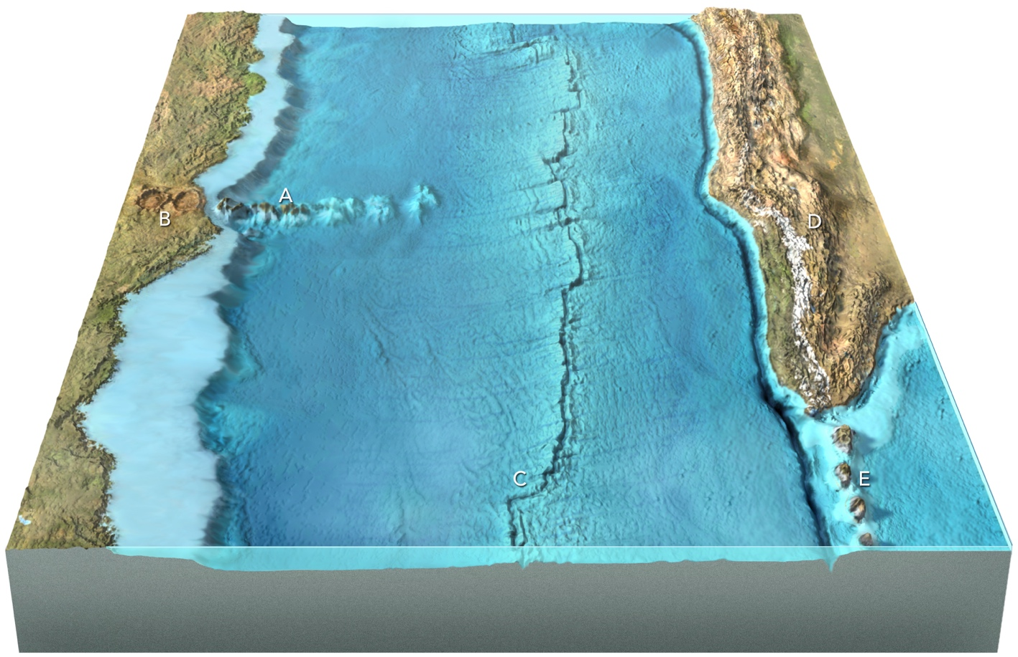

Site E: A chain of volcanic islands adjacent to an oceanic trench. The volcanoes erupt gray volcanic ash and lava flows. There are also some intrusive rocks. [Samples 8 and 9]

Site B: Circular volcanic depressions on land, which are filled with light-colored volcanic ash and light-colored volcanic rocks. [Samples 2 and 3]

Site C: A volcanic ridge that zigzags across the ocean floor. The rock sample is dark colored and is from a lumpy lava flow on the seafloor. [Sample 4]